1] Create group and user as given below

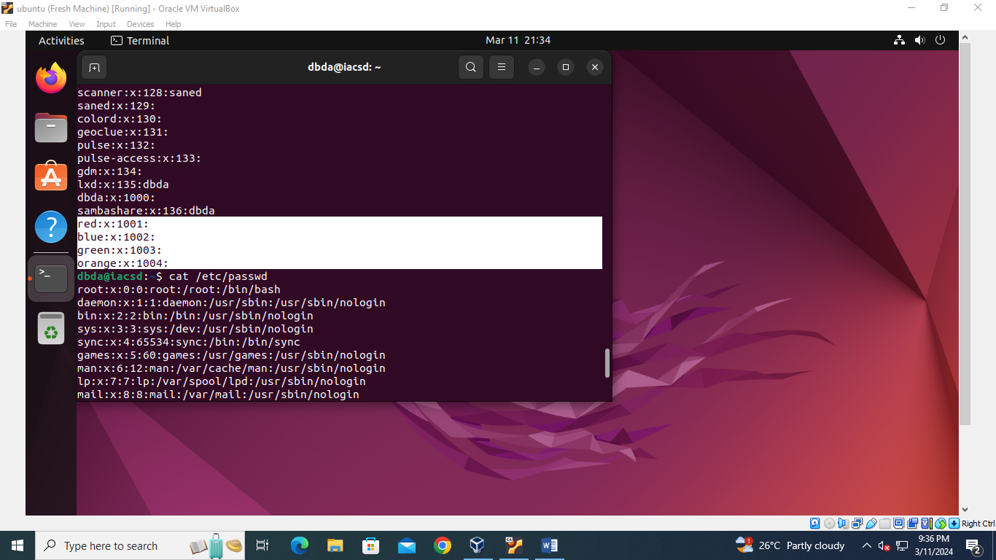

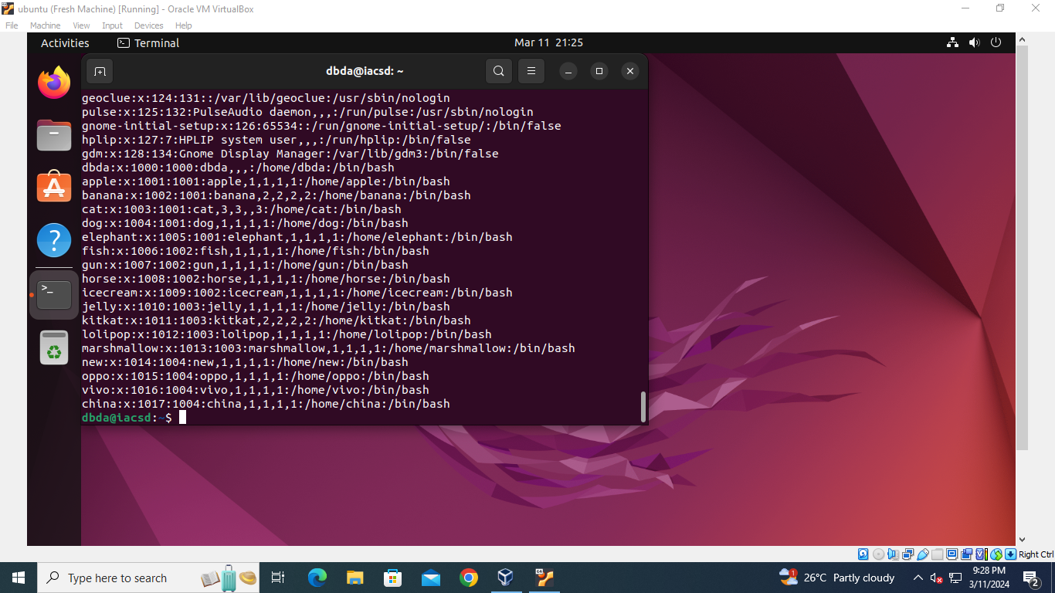

1. Create directory named EVERYONE in /home. Give all permission to EVERYONE

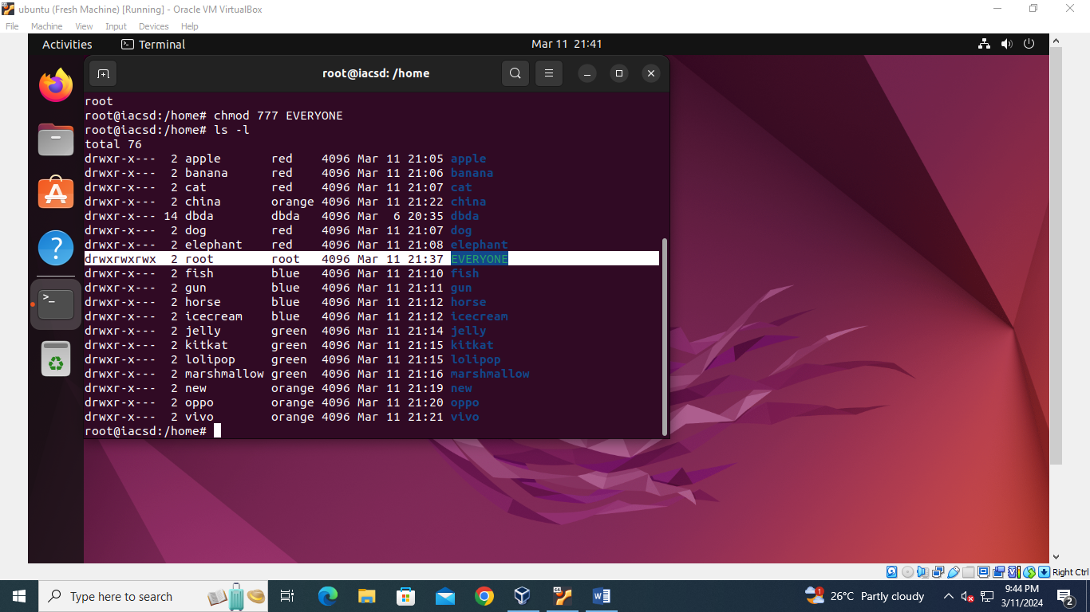

B] CREATE A FILE WITH EVERY USER(WHOAMI>>USERNAME.TXT)

oppo ->primary group change-> one

vivo -> primary group change-> two

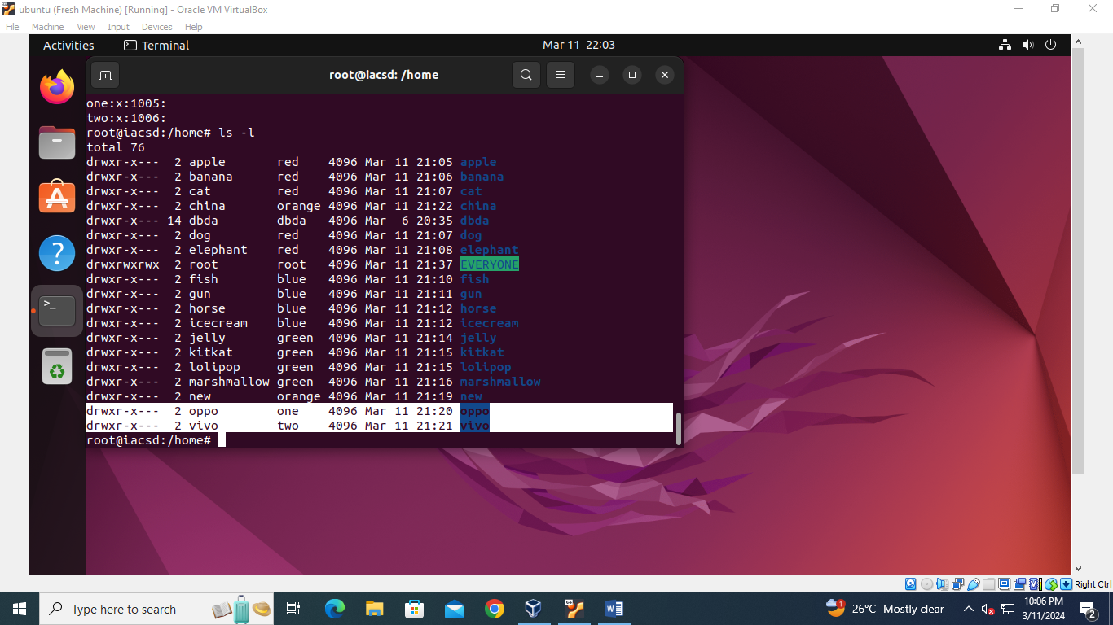

Jelly,kitkat,lollipop, marshmallow->add these users to sudo group

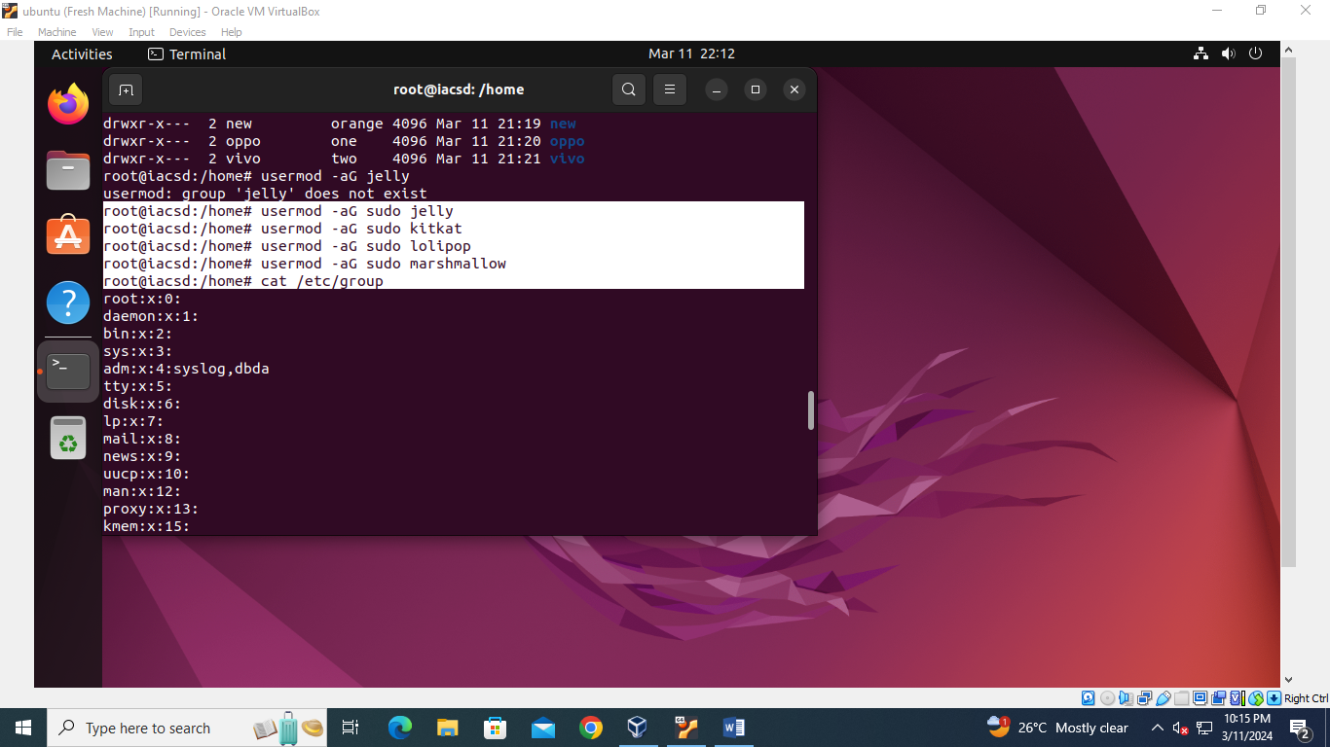

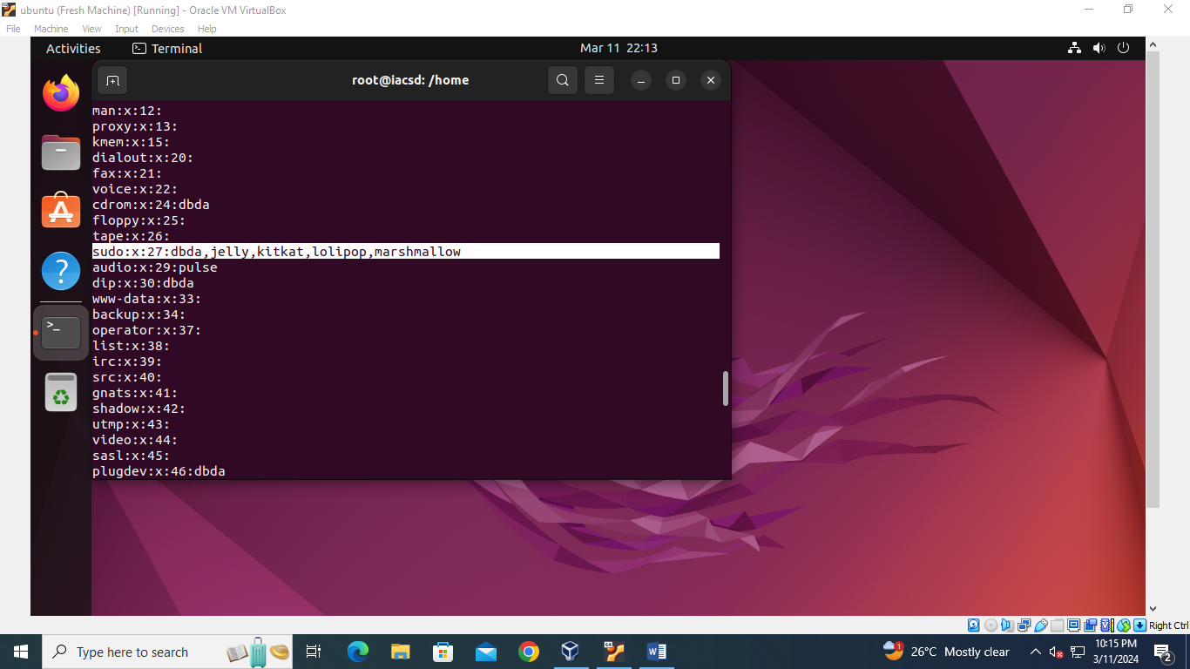

Fish,gun->add these users to one group as well as (secondary group)

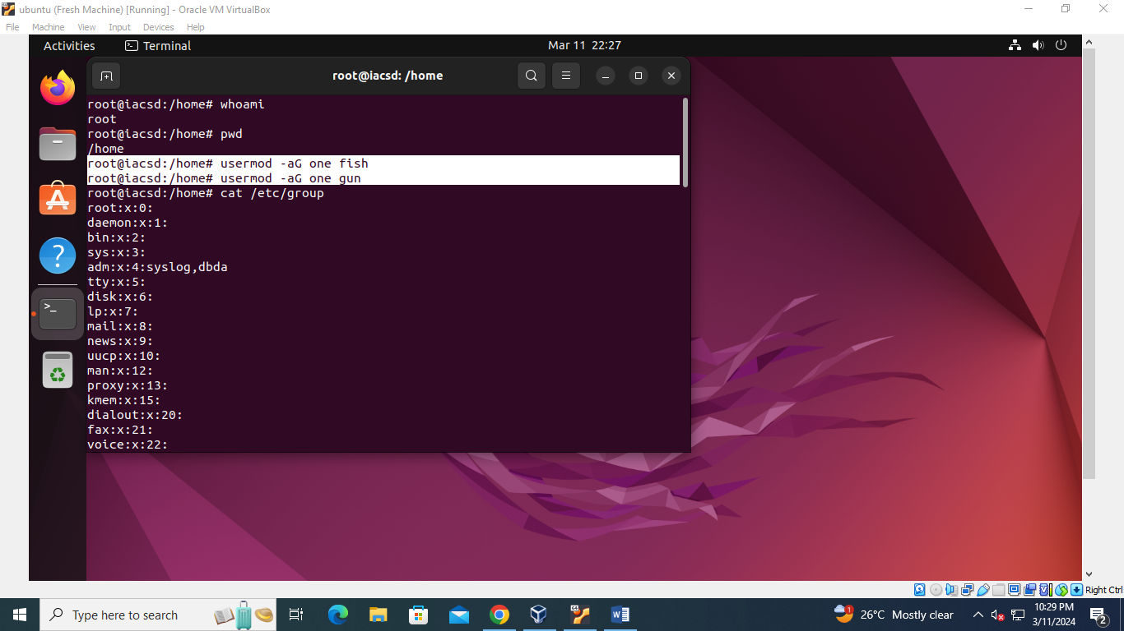

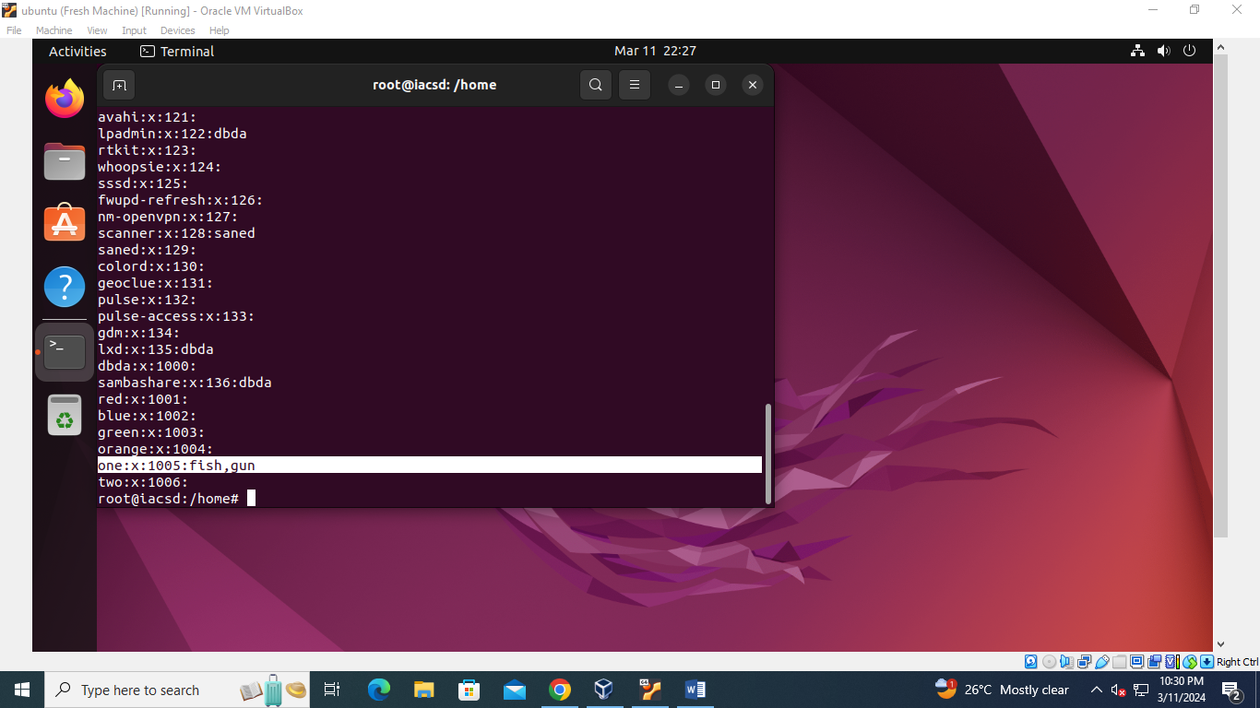

Q.2] Create Numbers.txt which will contain numbers from 1-50

a. display first 15 numbers

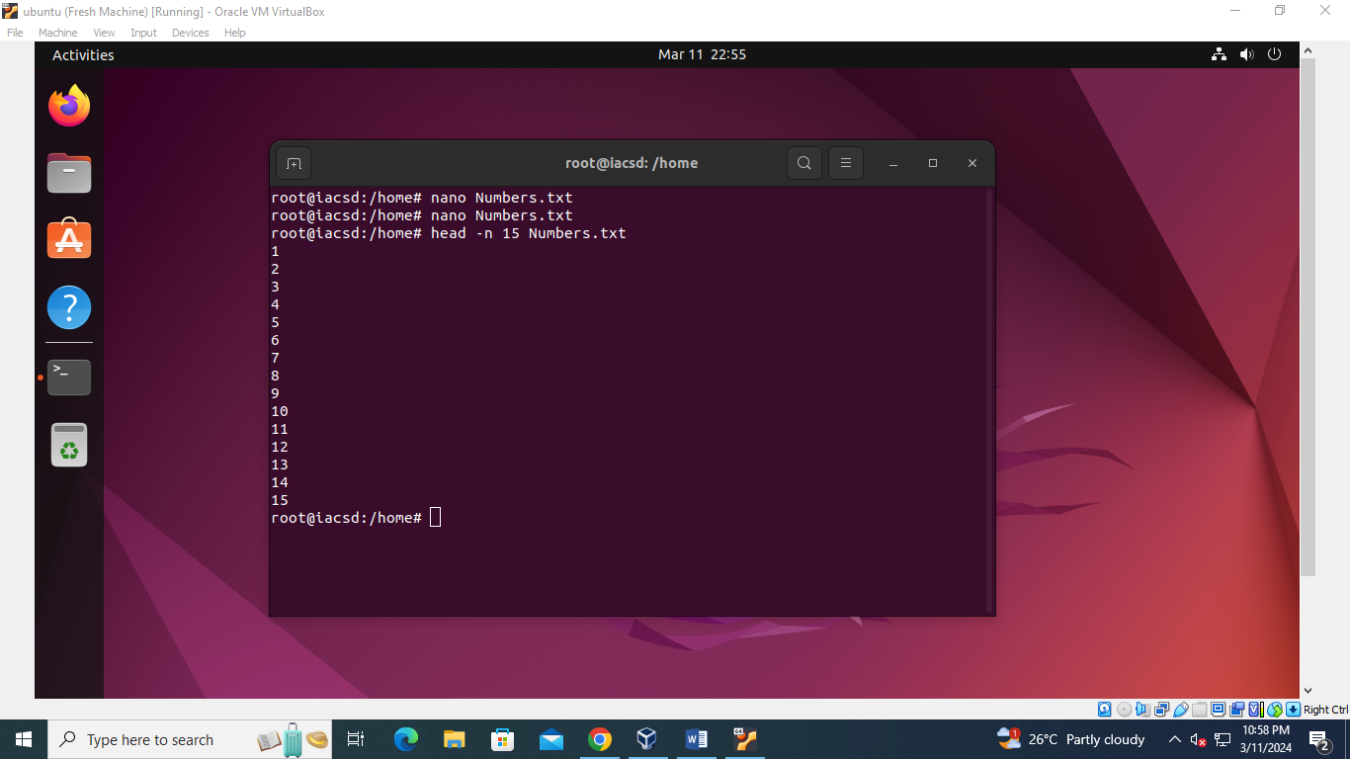

b.] display last 10 numbers

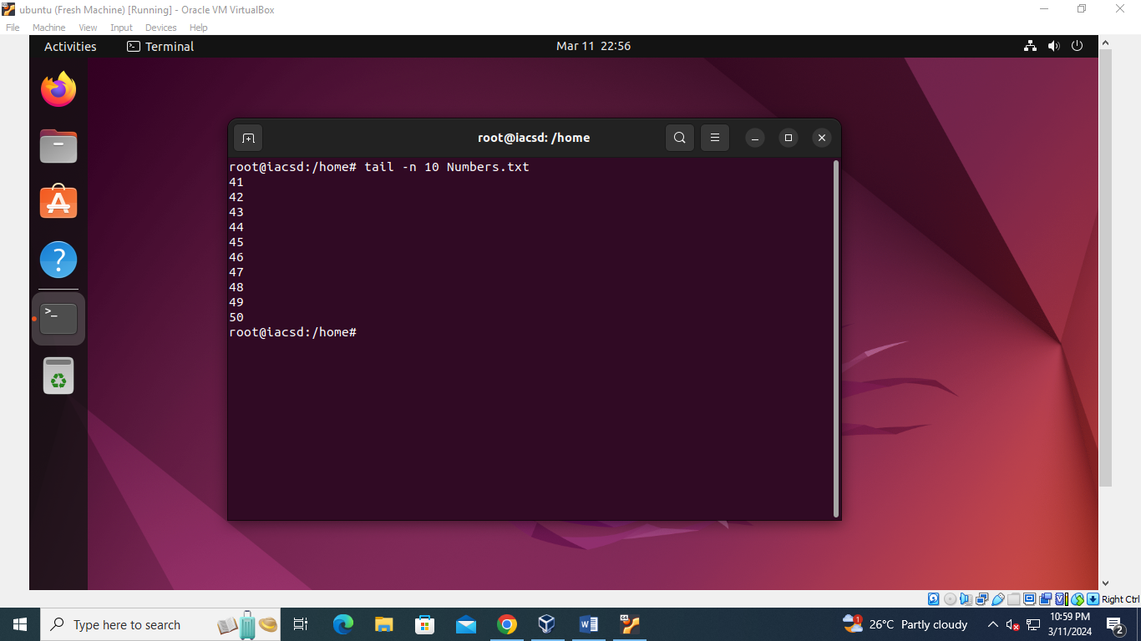

c.] display numbers in reverse order.

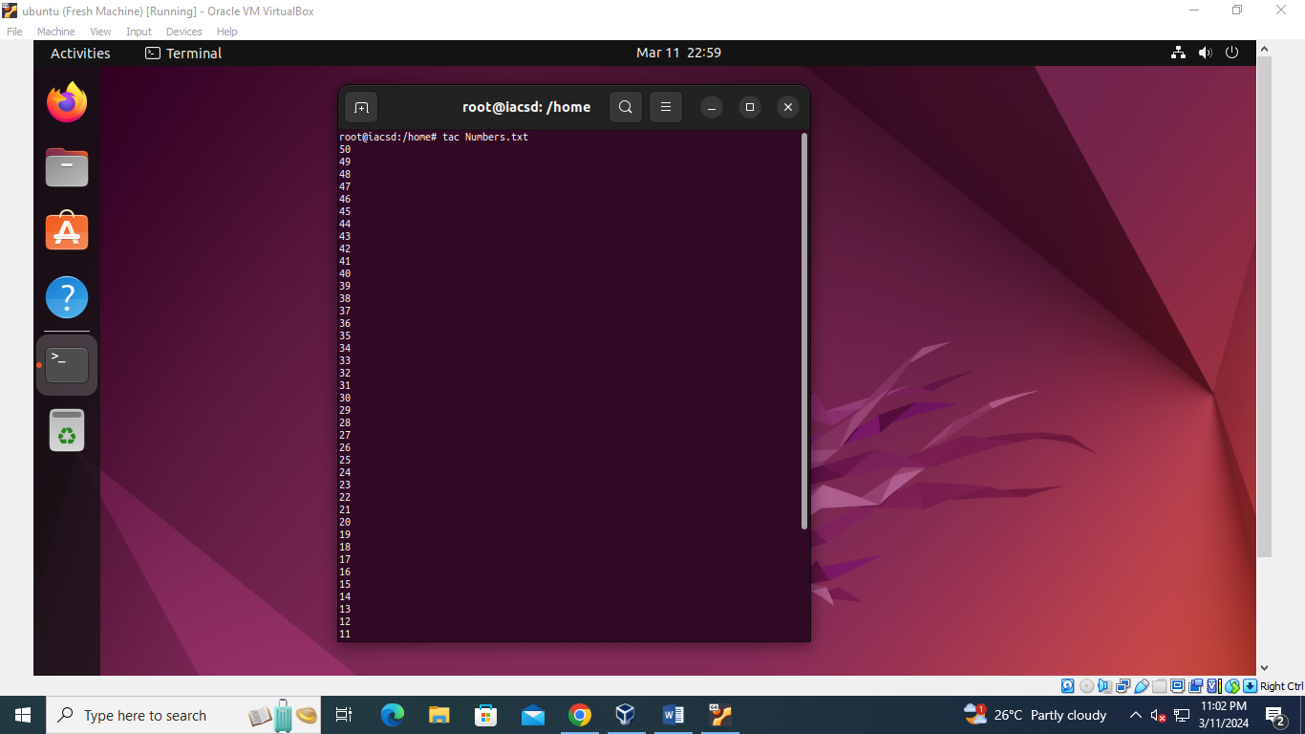

d.] display numbers which includes 4 in it.

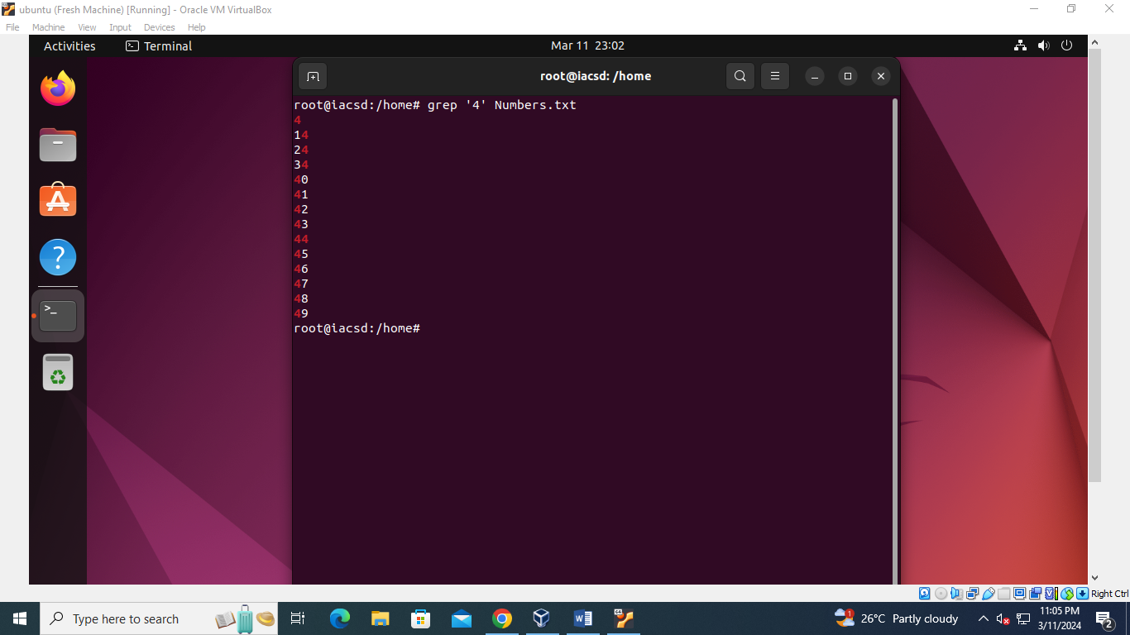

Q.3] Create Student.txt file as given below

Rollno:name:marks

1111:Ram:87

2222:Sham:69

3333:Teena:58

4444:Priya:74

1. Display only details of sham
2. B. display only marks of priya
3. Display total numbers of lines in student.txt

